18 July – 2024

Day 7

Now we create front-end application

This code please do inside frontend folder

npx create-react-app frontend-app

Or

npm install create-react-app

create-react-app frontend-app

cd frontend-app

npm install react-router-dom

npm install axios

front end technologies running on port number : 3000

backend technologies running on port number : 9090

cors policy : Cross Origin Resource sharing

AWS S3: (Simpe Storage Service) : it is a type of service which help share huge data with high secure, high available etc.

AWS S3 bucket : it is a like a container which hold any type of data txt, pdf, doc, jar ,war file, projects.

We uploaded simple text file.

We upload spring boot jar file.

Please create simple spring boot project with one end point or rest api.

After project creation done. Please create the jar file using eclipse IDE or using maven package command.

AWS EC2 instance : Elastic Compute Cloud : This module provide us Virtual Server Machine using any type of OS like window or non window. And we configurate all hardware for that machine while creating instance. Then we need to installed required software to run the application like Java, node, python etc. This machine provide us public IP Address.

Steps to create EC2 instance.

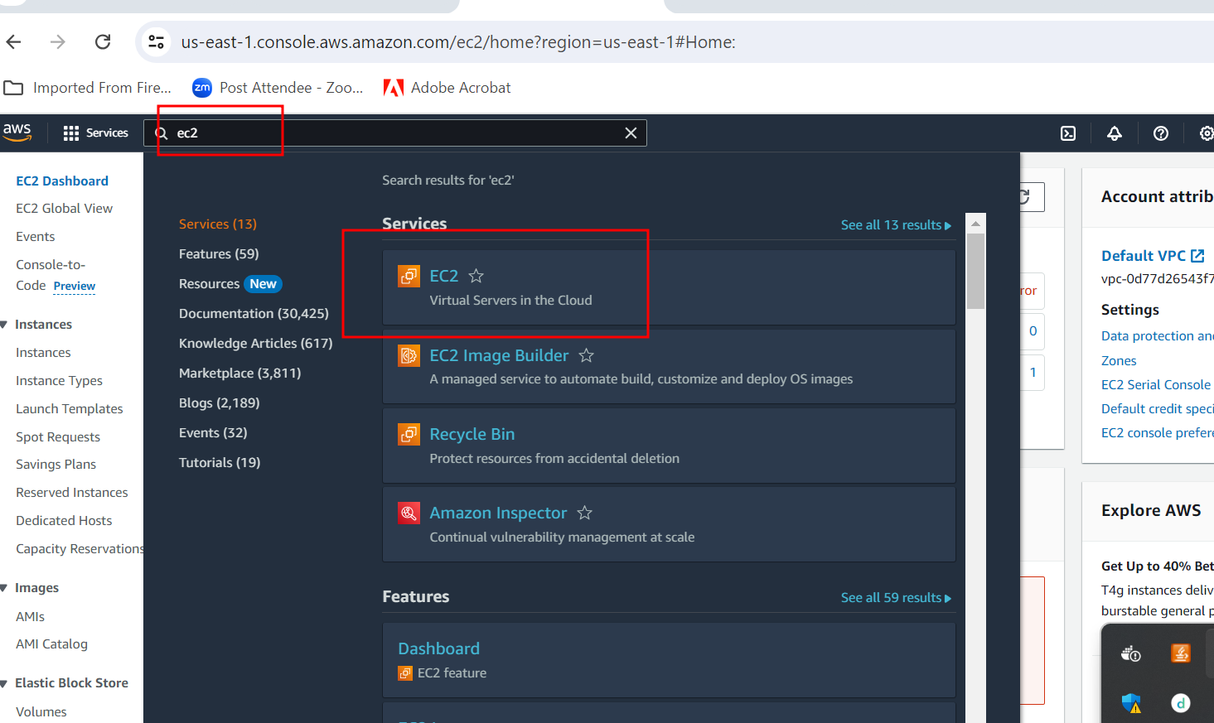

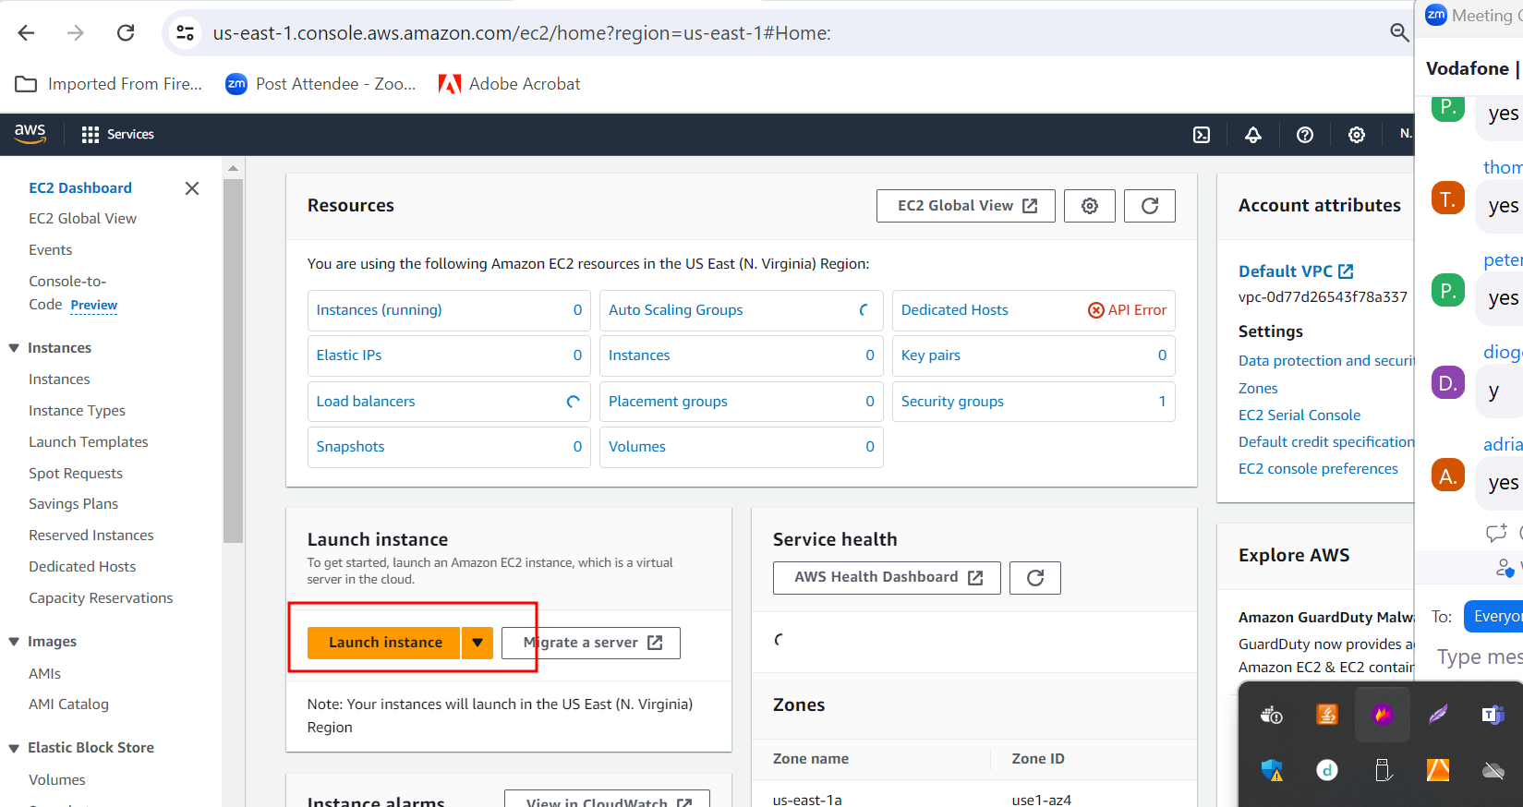

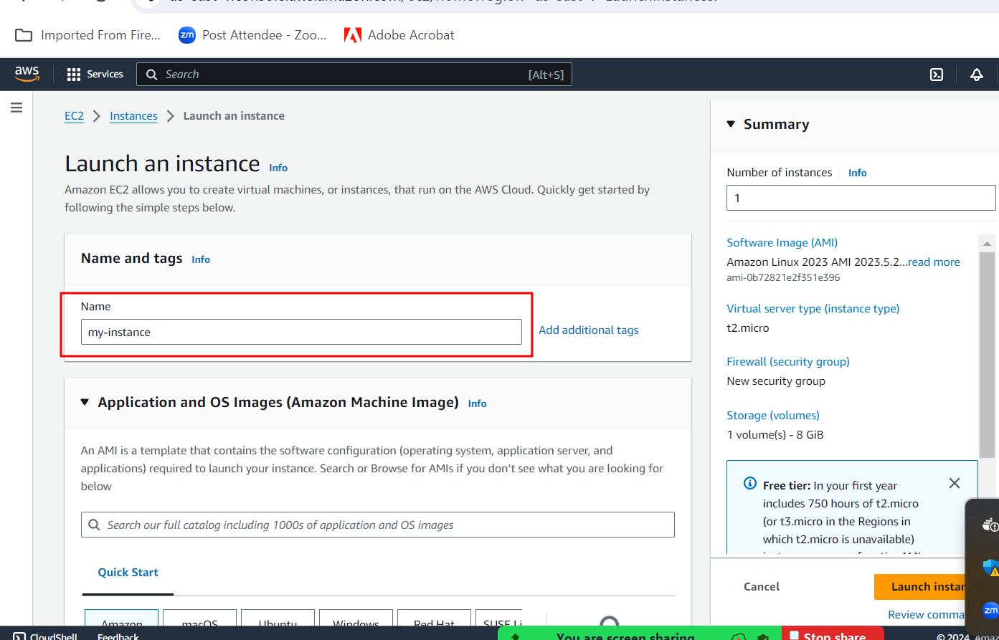

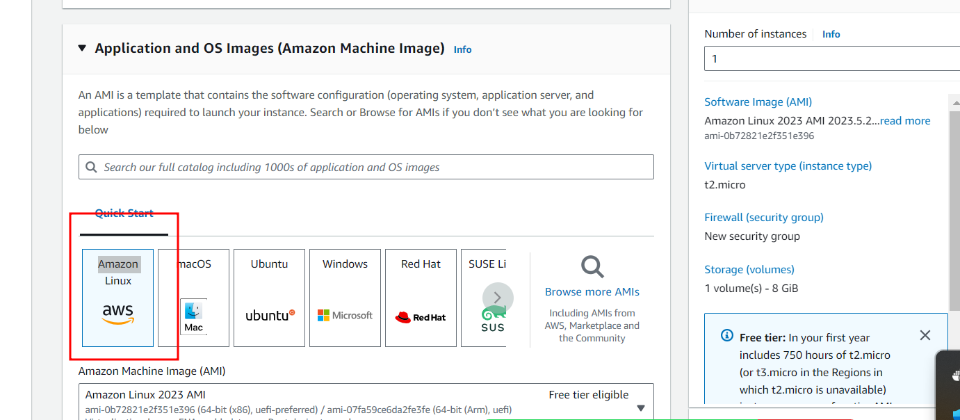

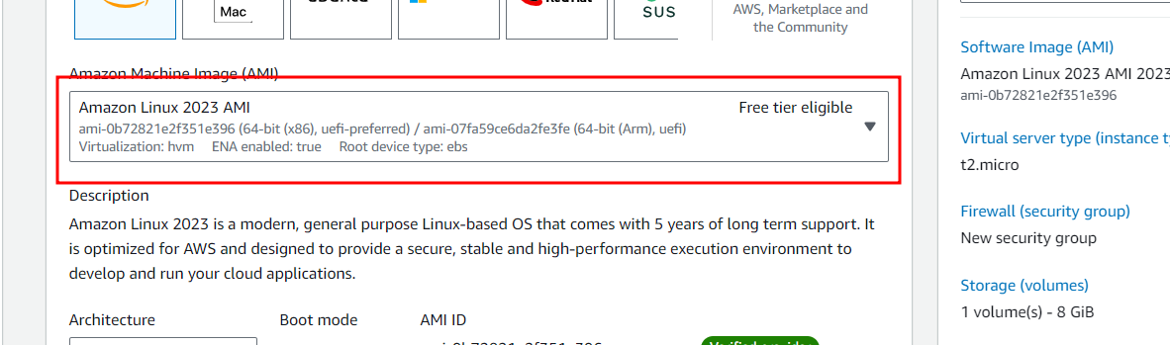

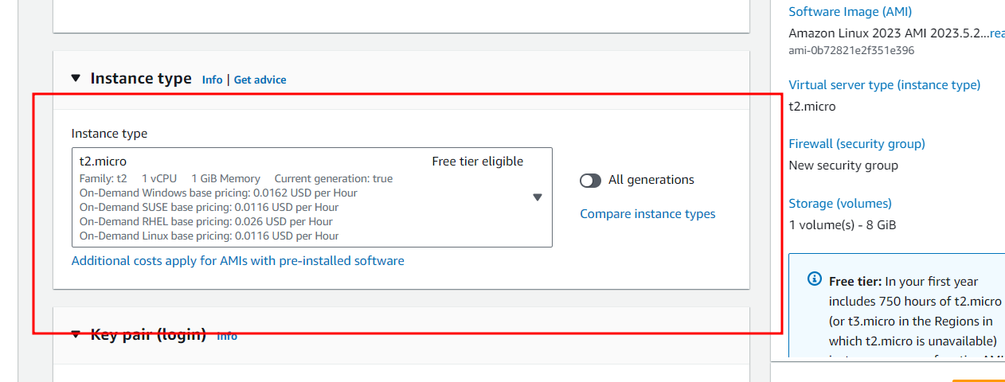

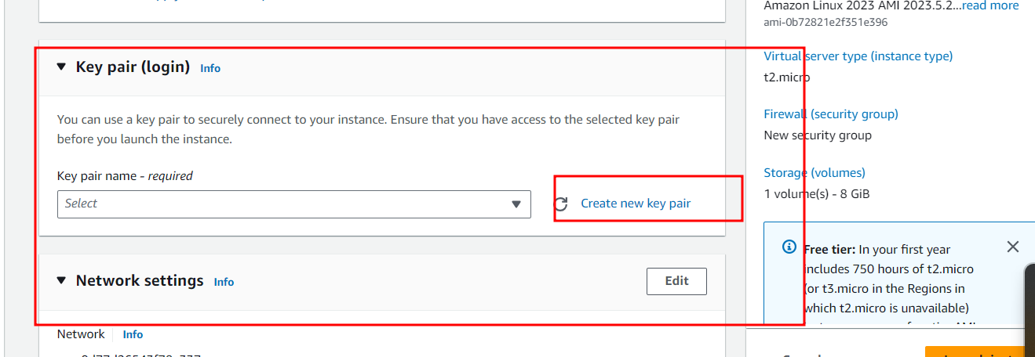

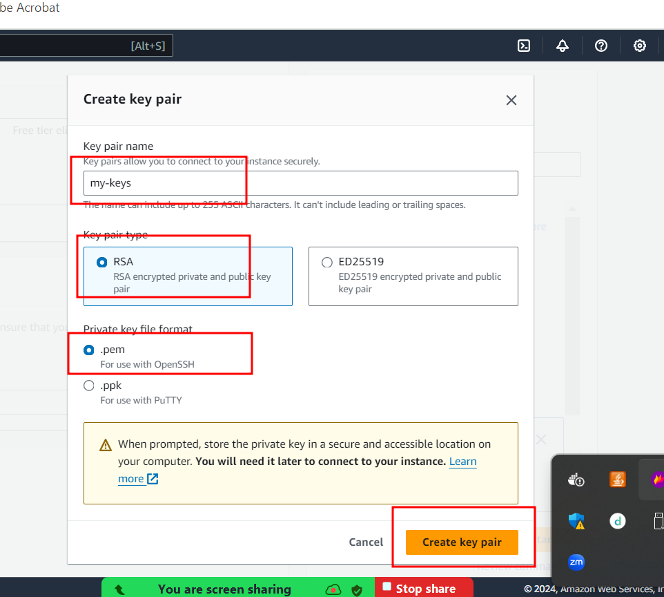

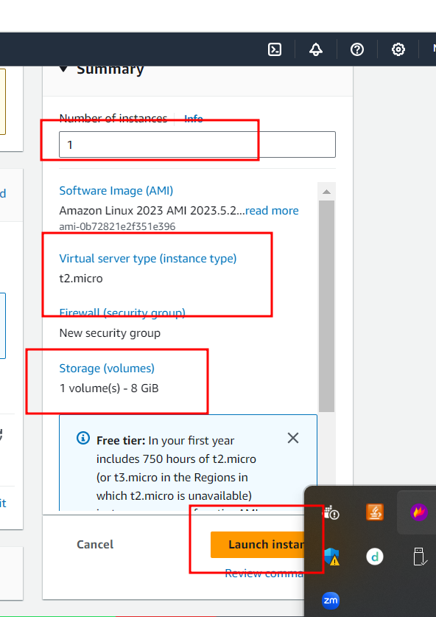

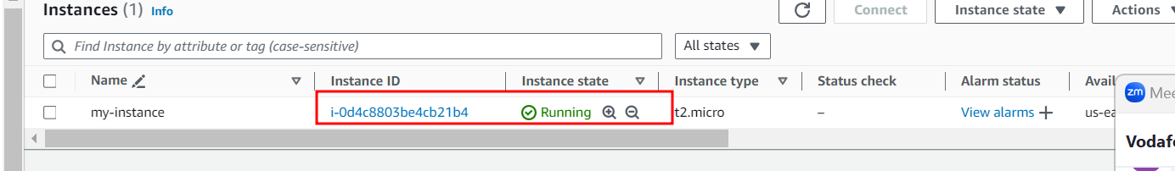

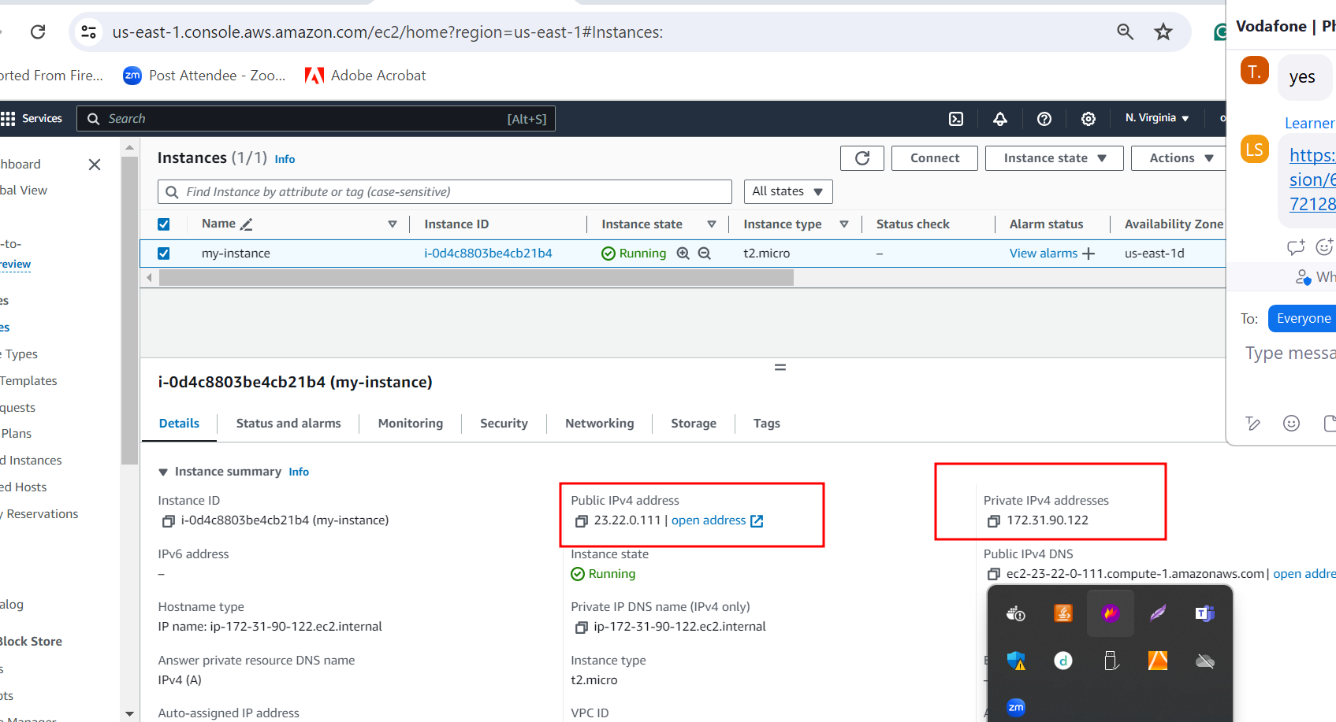

If you want to connect this machine using terminal or browser

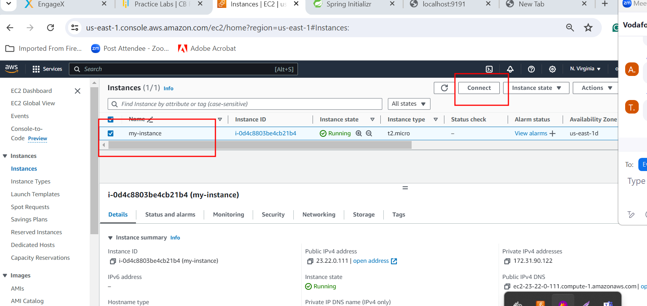

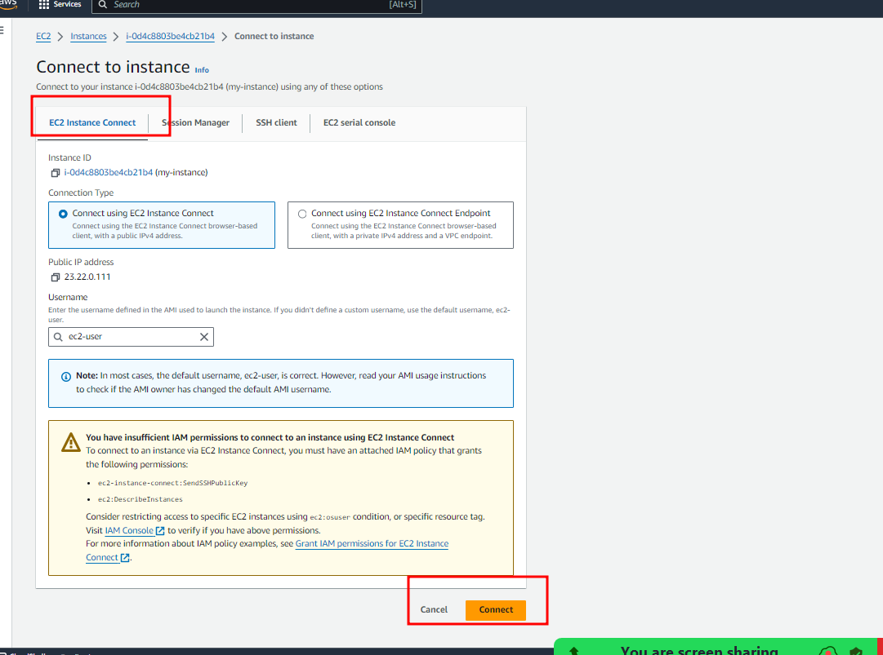

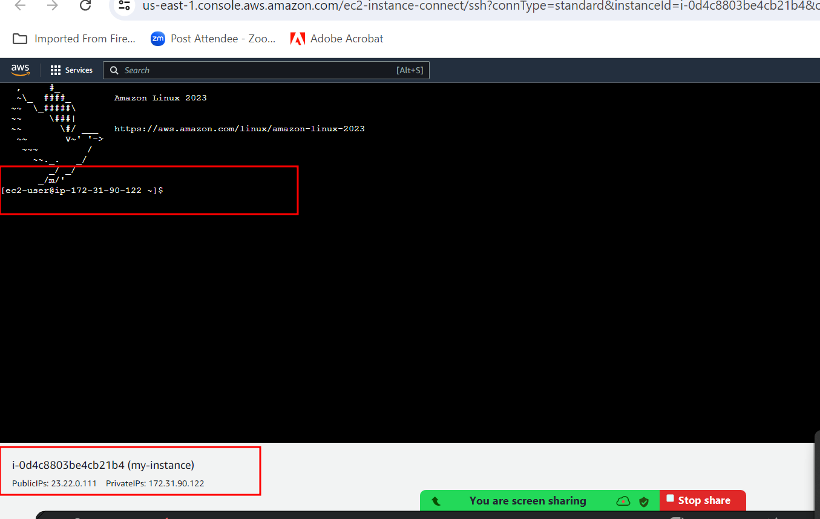

Using wget URL please download jar file from S3 bucket to EC2 instance machine.

To run this jar file in EC2 instance we need java software.

Installing java in EC2 instance using below command

sudo yum install java

after installed java please run the jar file using

java -jar filename.jar

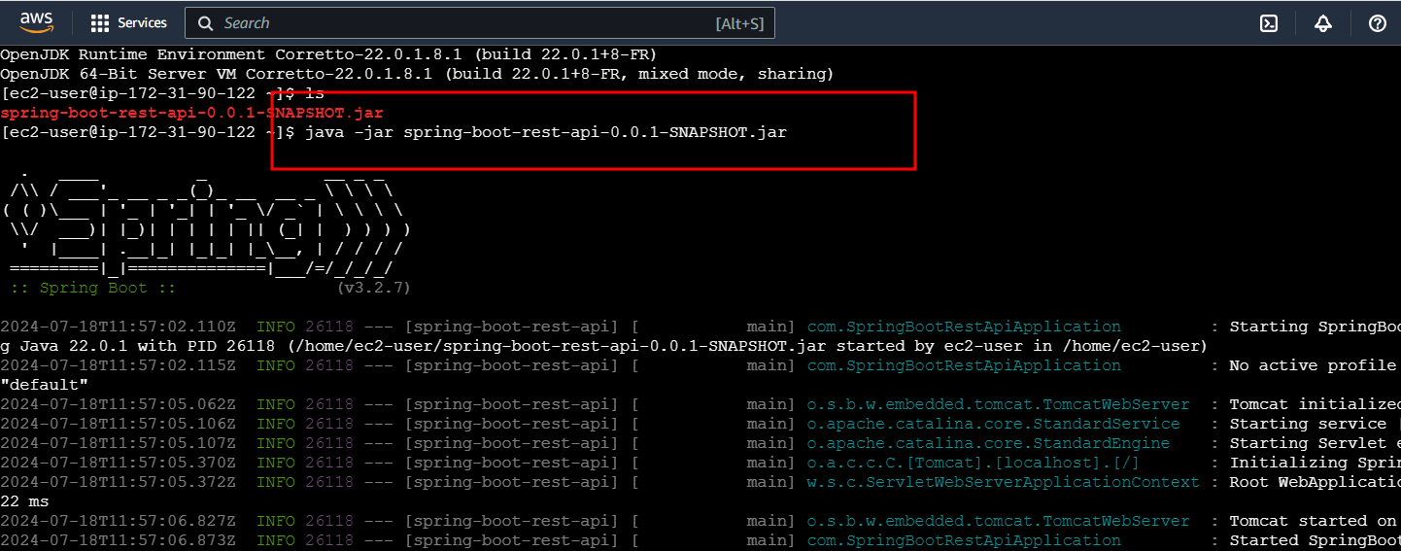

Application running on EC2 instance but 9191 port number block.

By default EC2 instance open only 22 port number for SSH client.

